EEZ DCP405+ power module wire harness

- AC power module cable
- DC power module cable

AC power module cable
Length | 200 (± 5) mm
Type | 0.75 mm² (18 AWG) single wire, stranded, min. 250 VAC
TME | Brown: H05VK075BR, Blue: H05VK075BL, Green-Yellow: H05VK075GN/GE
LCSC | –
Mouser | Brown: 602-3055-100-07, Blue: 602-3055-100-06, Green-yellow: 602-3055-100-28
Connectors
Side A | Mainboard (X10, X11 or X12) | Side B | AC/DC module power output
Housing type | Female, wire-to-board connector, 3.96 mm pitch | Housing type | Female, wire-to-board connector, 3.96 mm pitch
TME | VHR-3N | TME | VHR-3N
LCSC | C157899 | LCSC | C157899
Mouser | 306-VHR-3N | Mouser | 306-VHR-3N
 | 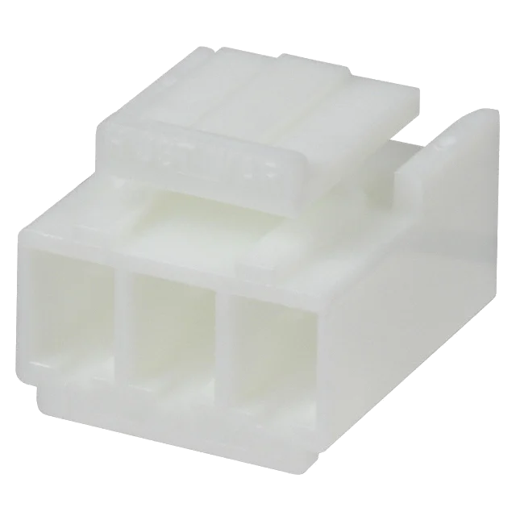
Pin | Female | Pin | Female
 | 3 | Pin quantity | 2 (middle position is not populated!)
TME | NS39-T | TME | NS39-T
LCSC | C160349 | LCSC | C160349
Mouser | 306-SVH-21T-P1.1 | Mouser | 306-SVH-21T-P1.1
 | 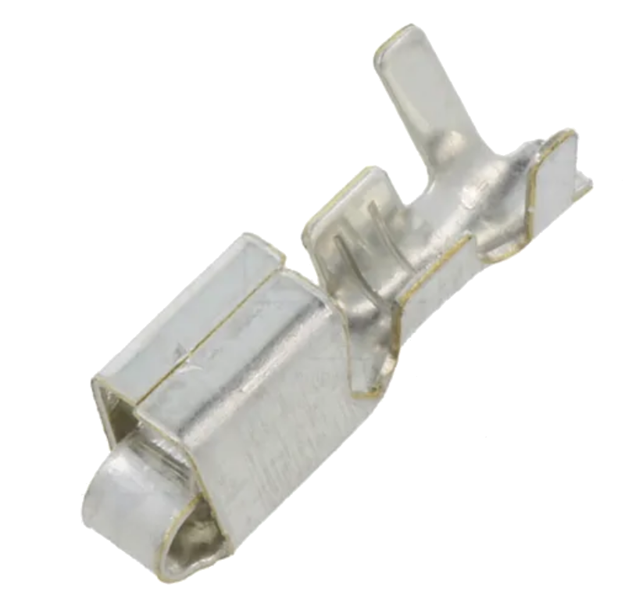
 |  | Insulated ring crimp terminal | Ring inside diameter 3.2 mm
 |  | TME | –
 |  | LCSC | C20232480
 |  | Mouser | 548-BU-190540035
 |  |  | 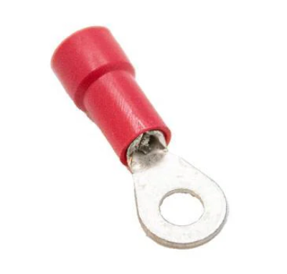

Picture

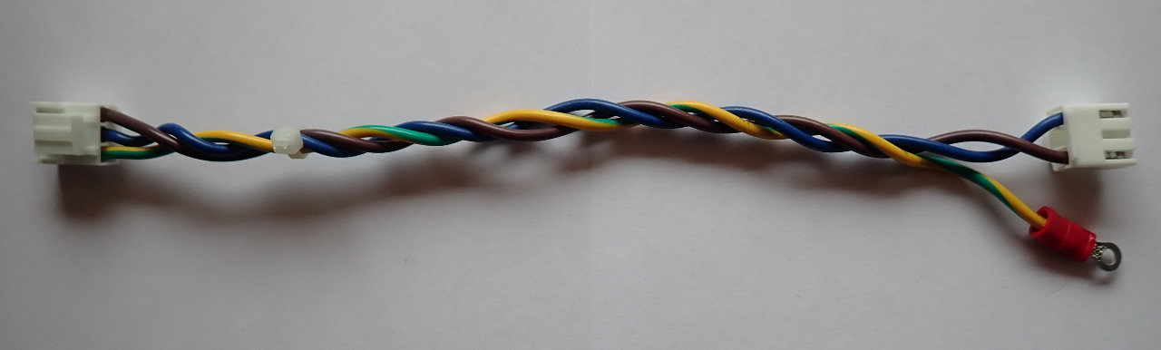

DC power module cable
Length | 370 (± 5) mm
Type | 0.75 mm² (18 AWG) single wire, stranded, min. 250 VAC
TME | Red: H05VK075RT, Black: H05VK075SW
LCSC | –
Mouser | Red: 602-3055-100-03, Black: 602-3055-100-02
Connectors
Side A | Power module (X3) | Side B | AC/DC module power output
Housing type | Female, wire-to-board connector, 3.96 mm pitch | Housing type | Female, wire-to-board connector, 3.96 mm pitch
TME | VHR-4N | TME | VHR-4N
LCSC | C157898 | LCSC | C157898
Mouser | 306-VHR-4N | Mouser | 306-VHR-4N
 | 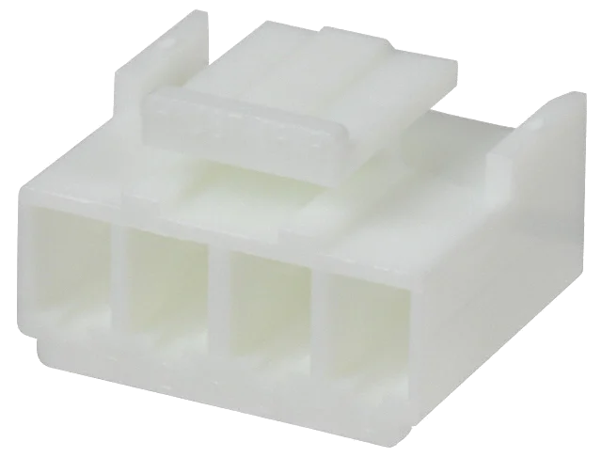
Pin | Female | Pin | Female
Pin quantity | 2 | Pin quantity | 2
TME | NS39-T | TME | NS39-T
LCSC | C160349 | LCSC | C160349
Mouser | 306-SVH-21T-P1.1 | Mouser | 306-SVH-21T-P1.1

Picture

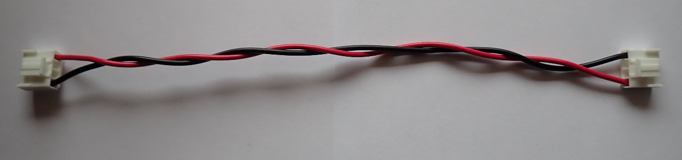
View of the AC/DC module mounted on the BB3+ top plate, with cables for the power module connected:

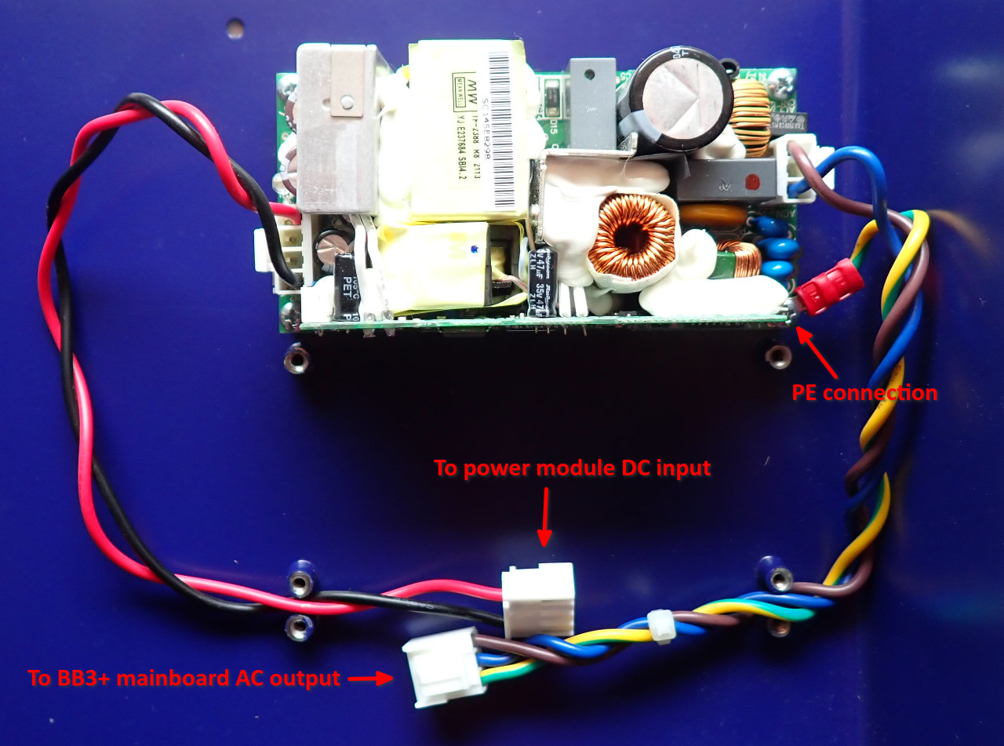

BOM
The following BOM includes items for connecting two power modules.

Type | Part (TME) | Part (LCSC) | Part (Mouser) | Total
3-pin header 3.96 mm | VHR-3N | C157899 | 306-VHR-3N | 2
4-pin header 3.96 mm | VHR-4N | C157898 | 306-VHR-4N | 2
3.96 mm pin | NS39-T | C160349 | 306-SVH-21T-P1.1 | 9
Ring crimp terminal | – | C20232480 | 548-BU-190540035 | 1
0.75 cm² wire (Brown) | H05VK075BR | – | 602-3055-100-07 | 0.2 m
0.75 cm² wire (Blue) | H05VK075BL | – | 602-3055-100-06 | 0.2 m
0.75 cm² wire (Red) | H05VK075RT | – | 602-3055-100-03 | 0.37 m
0.75 cm² wire (Black) | H05VK075SW | – | 602-3055-100-02 | 0.37 m
0.75 cm² wire (Yellow-Green) | H05VK075GN/GE | – | 602-3055-100-28 | 0.2 m

